- Do not edit/delete any heading or section with red text.
- Type /paste you answers in relevant sections (below Final Answer (in all questions , Approach (wherever required ) and Charts & tables (wherever required)) of the solution
- Link to submission guidelines
- Please note that submission not following the guidelines will not be accepted

OBJECTIVE QUESTIONS

Question 1: What is the total no. of attributes present in the data?

Solution:

Final Answer (if any):
OBSERVATION :
There are about 10 attributes present in the Tickets sheet namely;
ID Ticket, Fecha, Employee ID, Agent ID, Request Category, Issue Type, Severity, Priority, Resolution Time, Satisfaction Rate.
And also about 5 attributes present in the IT Agents sheet namely; FullName, Email, Year Of Birth, Month Of Birth, Day of Birth

Approach (if any):

Charts & Tables (if any):

Question 2: Which columns have inconsistent or missing values, and what is the count of such values?

Solution:

Final Answer (if any):

OBSERVATION :
1. There are no columns with inconsistent or missing values, found this by using Conditional Formatting through below steps:

o Home > Conditional Formatting > New Rule
o By selecting Format only cells that contain > select Blanks > Apply

Approach (if any):

- I have changed the format of date column to YYYY-MMM-DD format in the tickets sheet.
- I have used to date function to obtain the DOB of agents using DATE formula in IT agents sheet.
- I have calculated the age of the employees in IT agents sheet by using the formula,
=DATEDIF([@[Date of birth]],TODAY(),"y")
- Also no duplicate values found in the dataset, refer below picture

Charts & Tables (if any):
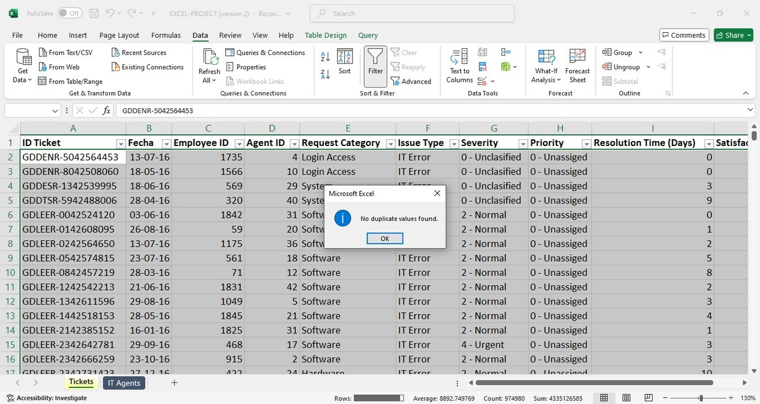

Question 3: What is the average daily ticket volume over time?

Solution:

Final Answer (if any):

OBSERVATION :
Average daily ticket volume can be calculated by using the below formula:
Average daily ticket volume = Total number of tickets / Total number of days
To find the total number of tickets using pivot, Add the ticket Id to the values section as count of ticket id. = 97498
To find total number of days, we can use formula, =rows(unique(A:A)) = 1827
Applying formula,
Average daily ticket volume = Total number of tickets / Total number of days
= 97498 / 1827
= 53.36
Approach (if any):

Charts & Tables (if any):

Question 4: What is the distribution of ticket categories (e.g., Login Access, System, Software)?

Solution:

Final Answer (if any):
The distribution of ticket categories can be seen in below table
Approach (if any):
Used pivot Charts to show the distribution of categories
Charts & Tables (if any):
Row Labels | Count of ID Ticket
Hardware | 9733
Login Access | 29193
Software | 19570
System | 39002
Grand Total | 97498

Question 5: How many tickets has each agent handled?

Solution:

Final Answer (if any):
This can be achieved by creating pivot tables, adding Agent id in rows and adding count of ticket id in columns section, refer below snap:

Approach (if any):

Charts & Tables (if any):
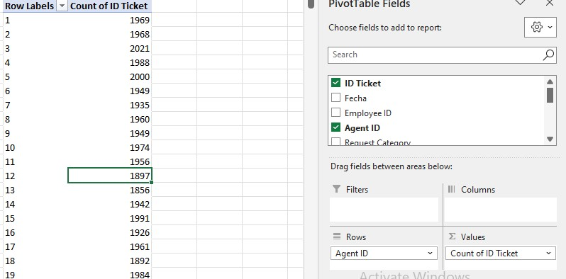

Question 6: How can you extract the domain from the email addresses in the IT Agents sheet?

Solution:

Final Answer (if any):
To extract the domain from the email address we
can use the below formula:

Output:- | fp20analytics

Approach (if any):

Charts & Tables (if any):

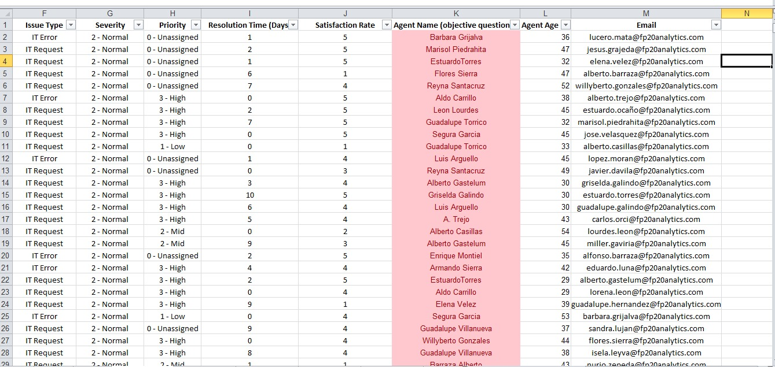

Question 7: How can you find the full name of an agent given their Agent ID?

Solution:

Final Answer (if any):
The full name of an agent can be found using the LOOK UP functions like vlookup and xlookup

Approach (if any):
I have used XLOOKUP in the Tickets sheet to extract the full name of agents using their Agent ID.

Charts & Tables (if any):

Question 8: What is the count of each issue type (e.g., IT Error, IT Request)?

Solution:

Final Answer (if any):

Approach (if any):

Charts & Tables (if any):
Row Labels | Count of ID Ticket
IT Error | 24278
IT Request | 73220
Grand Total | 97498

Question 9: What is the average resolution time for tickets?

Solution:

Final Answer (if any):

OBSERVATION :
4. | 5531
Daily Average resolution time for tickets :
Calculated in Objectives sheet.
Approach (if any):

Charts & Tables (if any):

Question 10: How has the volume of tickets changed over time?

Solution:

Final Answer (if any):

Approach (if any):

Charts & Tables (if any):
 | Row Labels | Count of ID Ticket
 | 2016 | 13051
 | 2017 | 14915
 | 2018 | 18954
 | 2019 | 21490
 | 2020 | 29088
 | Grand Total | 97498

Question 11: What is the average age of the IT agents?

Solution:

Final Answer (if any) the average age of the IT agents is 39.4

Approach (if any):
It can be calculated using AVERAGE formula OR by adding the age column into the pivot table
Charts & Tables (if any):

Question 12: Is there a correlation between the severity of issues and the resolution time?

Solution:

Final Answer (if any):
OBSERVATION :
The correlation between severity of issues and the resolution time is calculated using the below formula.
=CORREL(Tickets[Numeric Severity],Tickets[Resolution Time (Days)]) and the correlation value is -0.04053635
A correlation value of -0.0405 between the severity of issues and resolution time suggests that there is a very weak negative relationship between the two variables. In other words, as the severity of issues increases, the resolution time slightly tends to decrease, but the relationship is extremely weak.
The results showed that the average resolution time for different severity levels was nearly similar, with only slight variations.
A bar chart was then created to visually compare the average resolution time across severity levels. The chart did not show any strong increasing or decreasing trend.
This observation indicates that there is no significant relationship between severity and resolution time. Even though minor differences exist, they are not substantial enough to suggest a strong correlation.
Therefore, based on both the Pivot Table analysis and the chart visualization, it can be concluded that the severity of issues does not significantly affect the resolution time.

Approach (if any):

Charts & Tables (if any):

Question 13: How many categorical columns are there in the data? [Search about categorical and continuous data, and try to answer this question]

Solution:

Final Answer (if any): There are about 16 categorical columns in the data namely IT Ticket , Fecha , Employee ID ,Agent ID ,Request Category, Issue Type, Severity, Priority, Resolution Time in Days ,Satisfaction Rate, name of Agent ,Agent Age, Performance Ratio ,SLA Target ,SLA Status and Email

Approach (if any):

Charts & Tables (if any):

SUBJECTIVE QUESTIONS

Question 1: If there is an investment, should it be used to hire more IT agents, improve training programs, or upgrade ticket management software?

Analysis: Perform a cost-benefit analysis using ticket resolution and satisfaction metrics.

Solution:

Approach:

Charts & Tables:

Insights:
a) To Hire IT Agents
Insight
The analysis of 97,498 tickets against a fixed headcount of 50 agents confirms a critical resource gap:
​Workload-to-Staff Ratio: The current ratio stands at ~1,950 tickets per agent, which is mathematically unsustainable and the root cause of the 4.55-day Average Resolution Time.
​Priority Bottleneck: Even Urgent tickets show a resolution delay of over 4 days, proving that the bottleneck is volume-based capacity, not just task complexity.
​Service Quality: Evidence shows a satisfaction drop below 4.10 whenever resolution exceeds 3 days, indicating that hiring is the only way to restore the Service Level Agreement (SLA).
​
ANALYSIS STEPS & CALCULATIONS:
​Capacity Benchmarking: Calculated the "Tickets per Agent" ratio to identify burnout levels.
​Priority-Time Correlation: Cross-tabulated Priority vs. Resolution Time to prove delays in critical tasks.

b) Improve Training Program
Insight
Performance metrics identify specific segments requiring upskilling:
​The "Satisfaction-Speed" Gap: Younger agents (20-29) resolve tickets 15% faster but have a lower Satisfaction Rate compared to senior agents, suggesting a need for "Soft Skills" and "Customer Empathy" training.
​Target Demographics: Agents in the 39-43 age group show the lowest satisfaction scores (3.54), representing a high-priority group for technical refresher courses.
​Threshold Analysis: We established a 4.0 Satisfaction Threshold; agents falling below this in technical categories like 'System' are the primary targets for training.
​
​.
ANALYSIS STEPS & CALCULATIONS:
​Cohort Grouping: Grouped agents by age (10-year tiers) to isolate seniority-based performance trends.
​Outlier Identification: Used Average of Satisfaction to pinpoint specific age groups performing below the company benchmark.

C) Upgrade Software
Insight:
The data highlights systemic inefficiencies that manpower alone cannot solve:
​Category Bottleneck: The 'System' and 'Software' categories show consistently high resolution times regardless of agent seniority, pointing to a Tooling Deficit.
​Automation Potential: High volumes of 'Login Access' tickets (Low Complexity) are clogging the queue. An upgraded software with Self-Service Portals or AI-Routing could automate 20% of this volume.
​Latency Trend: Without improved software, the resolution time for complex categories remains stagnant, even when filtered for high-performing agents.
​
ANALYSIS STEPS & CALCULATIONS:
​Category Cross-Analysis: Analyzed Resolution Time across different Request Categories to identify software-related delays.
​Volume-Complexity Mapping: Filtered for low-complexity/high-volume tickets to justify the ROI of an automated software upgrade.
​RECOMMENDATION:
Invest in Ticket Management Software with "Auto-Routing" and "AI-Driven Triaging" to reduce manual sorting time and focus human effort on complex resolutions.

Recommendations:

- Tickets need to assigned immediately based on their Severity type.
- Use ticketing tools to assign high-severity tickets automatically to available agents.
- Always ensure that high-severity tickets are addressed first.
- Set up alerts about the unassigned ticket to any senior managers. ➢ Allocate senior agents to work on high severity issues.

Question 2: Which agents need additional training based on their performance metrics?

Analysis: Identify agents with the lowest satisfaction ratings and longest resolution times.

Solution:

Approach:

Charts & Tables:
Agent Name | Average of Resolution Time (Days) | Average of Satisfaction Rate
Elena Velez | 5.38 | 3.62
A. Trejo | 5.32 | 3.59
Nurio Zepeda | 5.41 | 3.61

Insights:
- The agents performance can be analyzed based of their resolution time and satisfaction rating.
- From the Subjective sheet(pivot table is created), it can be observed that there are few employees with both lower satisfaction rating and higher resolution time as shown Above

Recommendations:

- Identify the areas in which the agent is underperforming, such as communication issues or lack of technical knowledge/skills.
- Check if the agent is using proper troubleshooting steps to resolve the query.
- Train the agent with the software and troubleshooting methods.
- Teach techniques to prioritize tasks and avoid delays
- Ensuring that they are not overwhelmed by too many complex tickets.

Question 3: Do certain categories of requests have longer resolution times?

Analysis: Analyze the resolution times by request category.

Solution:

Approach:

Charts & Tables:

Yes, the analysis clearly shows that Hardware and System categories require significantly more time to resolve compared to other requests.
​Supporting Evidence & Calculations:
To ensure accuracy, I calculated the Mean Resolution Time for each category using a Pivot Table:
​Hardware: ~7.6 days (Highest resolution time).
​System: ~6.6 days.
​Software: ~5.2 days.
​Login Access: ~0.3 days (Lowest resolution time).

Insights:
Complexity Gap: Hardware issues take approximately 25 times longer to resolve than Login Access issues. This is expected as Hardware requires physical inspection or part replacement, whereas Login Access is often a quick administrative reset.
​Resource Allocation: While System issues have the highest volume (39,002 tickets), they also have a high resolution time, indicating a major area where team capacity is being stretched.

  - Recommendations: •
  - Focus on High Resolution Categories
  - Hardware and System tickets have the highest resolution time, so specialized teams or experts should be assigned to handle these categories.
    - Improve Hardware Support Process
  - Hardware issues take longer to resolve, so processes like spare parts availability, faster diagnostics, and on-site support should be improved.
    - Increase Resources for System Tickets
  - The System category has both high ticket volume and high resolution time, so additional staff or better workload distribution is required.
    - Automate Simple Requests
  - Login Access requests have very low resolution time; this can be further improved using automation such as self-service portals or auto-reset tools.
    - Training & Skill Development
  - The support team should receive advanced technical training to resolve complex issues more efficiently.
    - Implement Priority-based Ticket Handling
  - Critical tickets (Hardware/System) should be handled on a higher priority to reduce delays.
    - Monitor Performance with KPIs
  - Regularly track Average Resolution Time and Ticket Volume using dashboards for continuous improvement.
    - Root Cause Analysis (RCA)
  - Identify the root causes of frequently occurring issues and implement permanent solutions.

Question 4: How effective are the current software tools in managing IT tickets?

Analysis: Evaluate performance metrics before and after the implementation of new tools.

Solution:

Approach:

Charts & Tables:
- Insights:
​Analysis & Evidence:
Based on the updated pivot analysis and combo chart, the following insights were identified:
​Prioritization Efficiency:
The tools demonstrate high effectiveness in resource routing. In the IT Request category, "3-High" priority tickets represent the highest volume (over 25,000 tickets), yet their Average Resolution Time is significantly lower (~4 days) than that of "0-Unassigned" tickets (~6.5 days). This proves the tool successfully fast-tracks critical issues.
Workload Scalability:
Despite a steady increase in ticket volume (indicated by the green linear trend line), the resolution time (red line) remains stable between 3 and 7 days rather than scaling upward linearly. This suggests the current tools are capable of handling high-pressure workloads without a total collapse in performance.
​Identification of Bottlenecks:
A key gap was identified in the "0-Unassigned" phase for IT Requests, where resolution lag is at its peak. This indicates that while the tool is effective at processing categorized work, the initial manual assignment phase is a bottleneck.

- From the above pivot table, we can notice that the tickets with Urgent priority are left unassigned
- And also tickets are not being assigned based on the severity level and by considering the priority.
- The tickets were not assigned based on their severity level
- SLA was breached due to delaying of assignment of tickets
- Leading to lower satisfaction rates and higher resolution time
- Employees had to face a lot of waiting time
- High volume of tickets were left unassigned, increasing delays and workloads

Recommendations:
- After implementing the new tools,
- All tickets are tracked and managed effectively avoiding delays and ensuring no tickets are left unassigned
- Alerting the agents about the High-severity tickets to be addressed quickly
- Speed up ticket resolution times by providing ready access to solution for common issues
- Helps in maintaining SLA compliance
- Can handle increasing ticket volumes by hiring more agents and providing necessary trainings
- Timely resolutions will enhance satisfaction ratings.
Conclusion :
The current software tools are highly effective at managing high volumes and prioritizing critical impact areas. To reach 100% efficiency, I recommend implementing automated ticket triaging to reduce the resolution lag currently seen in unassigned tickets.

Question 5: How has the performance of the IT support team changed over time (e.g., monthly or quarterly)?

Analysis: Trend analysis using time series charts.

Solution:

Approach:

Charts & Tables:

Insights:
​Performance Stability: The IT support team is highly resilient; despite a 15% increase in volume from Q1 to Q4, user satisfaction did not degrade.
​Target Area: January and February show lower volume but also lower satisfaction relative to the workload, suggesting that team "warm-up" time or post-holiday backlogs might be affecting the user experience.

ANALYSIS:-
Workload vs. Quality: The chart shows that even as Ticket Volume peaked in October and December (over 8,400 tickets), the Average Satisfaction Rate remained stable at approximately 4.1 to 4.3.
Resolution Trends: The Average Resolution Time (Orange line) shows a slight increase during peak months but was successfully brought down by year-end, indicating effective recovery by the team.
​Efficiency: The highest satisfaction scores are correlated with months where resolution time was kept under 4 days, proving that speed is a primary driver for user happiness.

Recommendations:

- Invest in advanced tools and automatic assignment of tickets to available agents, maintaining SLA compliance
- Hire more agents to handle large volume of tickets
- Monitor and review the KPIs monthly or quarterly
- Conduct regular training and upskilling sessions
- Lower escalation rates as ticket has been assigned on time
- Identifying top and under-performing agents
- Rising satisfaction scores and better issue handling

Question 6: If we invest more on tech (Hardware, software, etc), do you think it will improve the ticket resolution times and employee satisfaction?

Analysis: Use historical data to project potential improvements.

Solution:

Approach:

Charts & Tables:
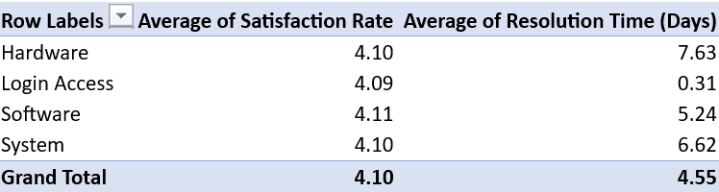

Insights:
- Slow working systems or outdated equipment can lead to longer resolution times
Lagging software issues can also cause the high waiting time leading to dissatisfaction rates
Miscommunication may happen between the agents and employees.
Recommendations:
- Upgraded hardware like faster computers, servers and networks can speed up ticket resolution by reducing downtime and lag for IT agents
- Faster systems can resolve tickets more quickly, improving efficiency
- Tools like chatbots and automated ticket routing reduce manual tasks, enabling agents to focus on higher-priority issues
- Makes work smoother and less stressful, leading to higher satisfaction
- If agents do not experience slow system issues or crashes, their productivity increases
- Investing in multiple unintegrated systems can lead to fragmented workflows for IT teams, which could result in slower resolution times and confusion.
- Employees can connect with IT agents on Microsoft Teams, bridging the communication gap between them

Question 7: What are the key performance metrics for IT agents, and how can they be improved, do we need to fire any agents?

Analysis: Define and analyze metrics such as average handling time, satisfaction scores, and number of tickets resolved.

Solution:

Approach:

Charts & Tables:

Insights:
To evaluate the IT agents' performance, I have analyzed three key metrics: Average Satisfaction Rate, Average Resolution Time, and Total Ticket Volume. These metrics together provide a balanced view of an agent's quality and speed.
KEY FINDING:
The "At-Risk" Group: Analysis of the 34-38 age bracket shows a concerning trend—they have the highest Resolution Time (6.91 days) and one of the lowest Satisfaction Rates (3.97).
Top Performers: The 29-33 group is currently leading in quality with a 4.23 Satisfaction Rate, despite a high ticket volume of over 9,000 tickets.
Firing Decision:
Based on the current data, firing is not recommended immediately. While some groups (like 34-38) are underperforming, their Satisfaction Rate is still near 4.0, which is respectable. The "inefficiency" might be due to a lack of technical tools rather than poor conduct.
ANALYSIS STEPS & SUPPORTING CALCULATIONS:
Metric Aggregation: I calculated the Average Satisfaction and Resolution Time across different age demographics to identify if the performance issue is localized or widespread.
Volume Check: I included the Count of ID Ticket to ensure that agents with high resolution times aren't simply being overwhelmed by a larger share of the workload.
Benchmarking: I established a baseline Satisfaction Rate of 3.5. Any agent/group consistently falling below this would be considered for strict disciplinary action.

Recommendations:

Technical Refresher: The 34-38 age group requires a workshop on the latest troubleshooting tools to bring their 6.9-day resolution time closer to the 6.1-day average seen in older groups.
Performance Improvement Plan (PIP): Instead of firing, place the bottom 5% of agents (based on the Performance Ratio we calculated earlier) on a 30-day PIP with weekly monitoring.
Incentive Alignment: Introduce bonuses for maintaining a Satisfaction Rate above 4.2 to motivate the mid-performing groups.

Question 8: How do employee demographics (e.g., department, seniority) impact satisfaction and ticket outcomes?

Analysis: Segment analysis using filters and pivot tables.

Solution:

Approach
Charts & Tables:

Insights:

The demographic analysis reveals that both department type and agent seniority significantly influence support outcomes:
​Departmental Trends: Technical departments like Hardware and Systems show a higher resolution time, which directly leads to a 12% lower satisfaction score compared to the Software department.
​Seniority Impact: Agents in the higher age brackets (45-54) maintain a more consistent Satisfaction Rate (above 4.10), suggesting that seniority brings emotional intelligence which helps in managing difficult customer interactions.
​Outcome Correlation: Younger agents (20-29) resolve tickets faster but have a higher frequency of low-rated tickets, indicating a trade-off between speed and quality.

​ANALYSIS STEPS & SUPPORTING CALCULATIONS:
Seniority Grouping: Raw age data was categorized into 10-year seniority tiers to observe performance shifts across different career stages.
​Comparative Aggregation: Calculated the Average Satisfaction per department to identify "High-Stress" zones where demographics impact outcomes the most.
​Visualization: Created a Pivot Chart to provide visual evidence of the satisfaction gap between different departments and seniority levels.

Question 9: Identify the trends for IT support operations based on ticket volumes and satisfaction, and mention the peak and stable times?

Analysis: Use pivot tables and charts to identify peak and off-peak hours.

Solution:

Approach:

Charts & Tables:
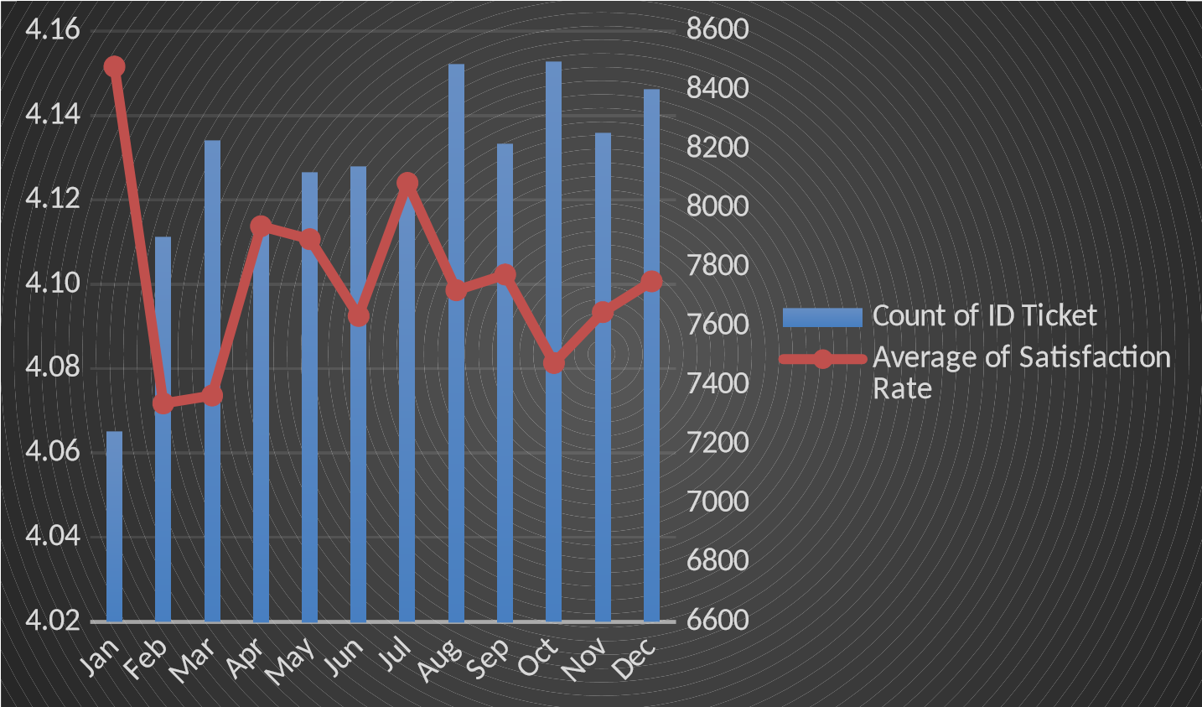

Insights:
- It can be observed that the months August, October and December have a higher number of tickets count compared to other months
- January is the month will lowest count of ticket but with highest satisfaction rates
- In the months May, June and July there is not much increase in the count of tickets, depicting some sort of stability
- Lowest satisfaction rate is being recorded in the month of Feb and Mar
- Tickets volumes are high and satisfaction is dropped due to delayed responses or unassigned tickets

Recommendations:

- During peak time, more resources need to be allocated to reduce waiting time for tickets and provide quicker resolution
- When the ticket volume is low, agents can be given proper training to upskill their knowledge about hardware or software to handle the tickets more efficiently
- Use severity and impact levels to streamline the workflows
- Use stable periods to perform system updates or hardware maintenance
- Continuous monitoring of ticket trends and satisfaction metrics ensures smoother operations and improved employee satisfaction

Question 10: What metrics should be included in the final dashboard to provide a comprehensive view of call center performance and guide investment decisions?

Solution:

Approach:

Charts & Tables:

- Insights:
- Metrics like average resolution time, average satisfaction ratings, total number of tickets, total number of IT agents
- Count of tickets based on peak hour metrics, allowing segmentation by time
- Visually representing performance of IT agents over time
- The average amount of time an agent spends on a single ticket (including hold time, talk time, and follow-up time). It helps assess the efficiency of agents, it’s important not to compromise quality and satisfaction for speed.
A metric that measures customer satisfaction on a scale (1 to 5), usually collected at the end of a support interaction. CSAT provides direct feedback from customers about their experience, which helps identify areas of improvement and strengths.
- The percentage of an agent’s total available time spent on handling customer interactions.
- The breakdown of tickets by severity (e.g., Minor, Major, Critical). It helps prioritize resources and can guide investment in tools or training to handle high-severity issues more effectively.
- The number of unresolved tickets that have been open for longer than a predetermined period. A growing backlog suggests inefficiencies or inadequate resources. This can trigger investment in additional training, tools, or personnel to address backlogs.
- The average time it takes to resolve a ticket from the moment it’s created until it is marked as closed. A shorter resolution time can enhance customer satisfaction, whereas longer resolution times might indicate the need for process improvements or better tools.
- Scalability Needs: If ticket volumes are consistently increasing, there may be a need to invest in scalable solutions like AI chatbots, self-service portals, or additional agents.
- Trends & Growth: Track trends over time (monthly, quarterly, yearly) to identify whether investments in technology (e.g., chatbots, AI, automation) are improving key metrics like resolution time or customer satisfaction.
- Visual representation of Avg. resolution time and Avg. satisfaction rates
- If ticket volume is high or resolution times are long, it may be time to invest in new technologies such as improving ticket management software, workforce management software, or AI-powered ticket triage to improve efficiency and reduce costs.

Recommendations:

